FST Advisory Committee
Meeting Agenda

Date: 06/02/2025

Attendees:

Old Business

- Update Skills/Tests: Cindy Oostra
- Certs Update: Breanna Gibson
- Training Update; Trevi Hardy
- Academies Update: SRV , South County Fire Conference
- ISP HAZMAT for LE
- FST Training Coordinator Position
- Budget/ Possible Rope/Extrication Trailer Purchases
- 1403 Live Fire/ Instructor II
- FST Forms/FST Website Update
- IFCA May 15-18/ Brad Terry Attend
- Central Idaho Fire Academy/ Donnelly, Idaho/ September 26-28, 2025
- Ricky Rescue/ Contracted Training acceptable programs.
- Official IFSAC Accreditation Letter was received in May. Accredited until 2030.
- Rope Rescue Curriculum

New Business

- Update Skills/Tests: Cindy Oostra
- Certs Update: Breanna Gibson
- Training Update; Trevi Hardy/ Brad Terry: YTD 260, May 36, June 19
- Academies Update: SRV , South County Fire Conference
- ISP HAZMAT for LE
- FST Training Coordinator Position: Interviews June 4-5.
- Budget/ Rope/Extrication Trailer Purchases/ Prop Repairs and Purchases
- 1403 Live Fire/ Instructor II Meeting Tuesday June 3rd.
- FST Forms
- FST Website Update
- IFCA May 15-18
- Rope Rescue Curriculum
- IFCA Website Training Forum

Next Advisory Council Meeting: July 7, 2025
Jul 7, 2025 01:00 PM Mountain Time (US and Canada)
ZOOM Link:
https://us02web.zoom.us/j/82665069493?pwd=bmYknvFftZXwqmpb9SGGBbrQIYJQR5.1
Security: Waiting Room
Passcode: 687858
New Meeting ID 826 6506 9493

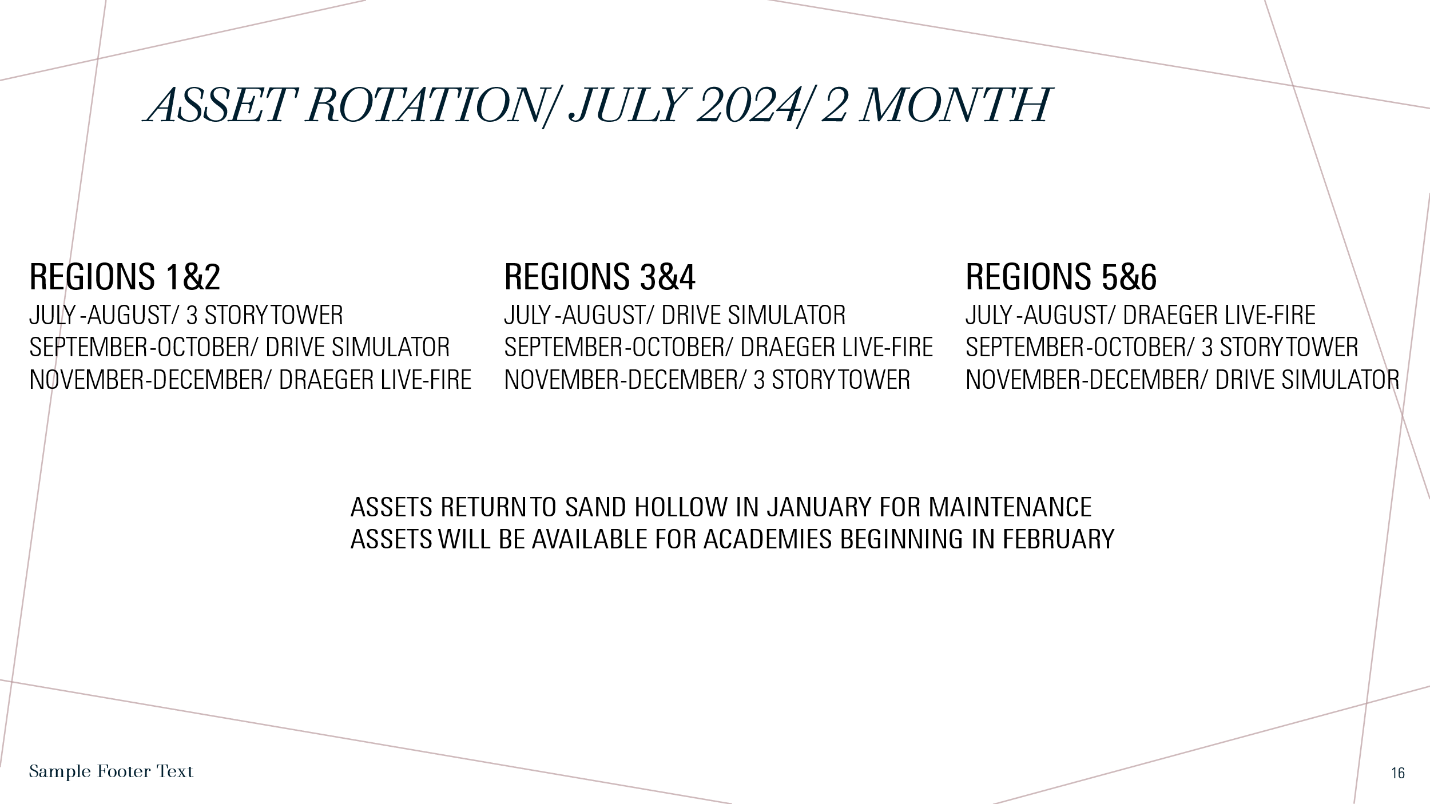
.
ASSET/ Training Prop Update.
06/02/2025
Draeger-Sand Hollow Move To Rock Creek Toby Robinson June 2, 2025
3 Story Tower-Sand Hollow Move to South County Fire Conference June Tim Atwood
Drive Simulator-Central Fire
Draeger From Rock Creek to SCFC Downey Wynn Whitmeyer June 19, 2025

Repair/Replace Updates

