FST Advisory Committee
Meeting Minutes

Date: 05/05/2025

Attendees:
- Brad Terry, Travis Myklebust, Steve Berg, John Miller, Jamie Hoover, Brandon Bake, Mark Mendez, Breanna Gibson, Cindy Oostra, Trevi Hardy, Darren Raskopf, Ben Doman, Keith Weissenfels, Jamie Hoover

Old Business

- New Council Members; Ben Doman Industry Fire Agency Alternate, Replace Nick Terry. Sergeant Brandon Bake- New ISP Advisory Council Representative and Training Contact for ISP. Replace Deshan Cabong.
- Clearwater/ Update
- ISP HAZMAT Operations for Law Enforcement
- 1403 Live Fire/ Instructor II / 1403 Lead Instructor Work Group.
- Update Skills/Tests/ Surveys/ Foam Eductors for D/O/ Lead Evaluator Coordination/ 13 Upcoming Events
- Certs Update: Testing/ Training 472 Clearwater, 1252 total March
- Academies / SRV/ South County Fire Conference
- Training Equipment/ User Guide Inventories Help
- NFA/FEMA NFPA 1400 Class Kootenai Co Cancelled
- ISP HAZMAT for Law Enforcement
- FST Processes/ Forms/
- SOG Update.

New Business

- Update Skills/Tests: Cindy Oostra
  - Cindy addressed driver operator foam inductors issues on JPRs. On board Apparatus Eductors are acceptable
  - Sent out evaluator survey to update contact information with over 50 responses
  - Working on updated exams for Firefighter 1. Almost complete for new standard. Three written tests completed and skills portion halfway done
  - New Skill Sheet formatting includes space for second evaluator signatures on evaluation forms for a failed skill.
  - All signatures moved to front side of skill sheets
  - One skill removed (don/doff PPE) as it's covered in other skills
  - Still seeking more input (instructors) for driver operator evaluations
IFSAC Evaluator Project:
- Cindy sending information about evaluator opportunities in candidate emails
- Creating a specific application process for evaluators with training officer recommendation. Currently 20 people waiting for becoming evlauators.
- Many applications coming in from regions one and two
- Certs Update: Breanna Gibson
  - Breanna Gibson issued 192 Training and 173 IFSAC Certs.
- Training Update; Trevi Hardy
  - Trevi helping revise processes while filling in as the Training Coordinator
  - Multiple courses in progress: 7 ready to close out and 25 in delivery or ready for delivery
  - Reminder to turn in course documents to complete courses and issue certs.
  - Looking for instructors with call outs for courses in regions one and two
  - Thank You to Travis for helping to find Instructors for Rope and Driver classes for Shoshone Fire in Region 1.
  - New Website electronic enrollment and evaluation forms being developed to replace paper forms (Cindy Oostra was the lead in starting the forms)
  - Forms can be completed on cell phones or laptops
  - Electronic forms will allow better data collection and analysis
  - Planning to pilot forms in upcoming courses after success with SRV academy class.
  - Discussion about providing feedback to instructors from evaluations. The lectronic form can create a report from each class and provide it to the instructor. It will have a better overall data collection.
  - Jamie Hoover asked how the instructors will receive the evals. Trevi provided the reports will be sent out to the instructor.
  - Trevi will use the Evals from Jamie Hoover to look at the data.
- Academies Update: SRV , South County Fire Conference
  - Upcoming academies: South County Fire Conference HOT in June with hot Academy (20-22). Other classes were conducted from April-May.
  - Discussion about trailer logistics for South County live fire training. Both Ammon and FST Live Fire Trailers will be at Downey SCFC.
  - Central Idaho Fire Academy in Donnelly returning in September 26-28, 2025. Will have to coordinate Prop Moves with the rotation.
- ISP HAZMAT for LE
  - Hazmat for law enforcement work group established with Rick Reddy, Brandon Bake, and Roy Mitchell. Meeting 5/21/25
  - Focus on determining appropriate training level requirements for law enforcement
- FST Training Coordinator Position
  - 30 applicants for vacant FST training coordinator position received
  - 16-18 applicants meet the emergency services experience requirement. Top 8-9 Interviews.
  - Interviews planned for week of June 4-5.
- Budget/ Possible Rope/Extrication Trailer Purchases
  - Budget update: looking good with enough funds to either update rope trailers or extrication trailers
  - Extrication trailers likely to be prioritized first due to frequency of requests
  - Plan to have rope rescue purchases by July-August
- 1403 Live Fire/ Instructor II
  - 1403 Live Fire and Instructor 2 work group established: Travis Myklebust, Bill Deruyter, Cody Trosky, Jamie Hoover, Mike Mather, Keith Weissenfels
  - 1403 Live Fire Instructor Meeting set for Tuesday, June 3, 2025 at 10:00 AM MST
- FST Forms/FST Website Update
  - New forms added to the testing side of the website
  - New IFSAC breakdown form added to explain certification flow
  - New informational form on what to expect when hosting an exam
  - Now sending email reminders to candidates the week of their exam
  - Working on developing their own website for better control and responsiveness
  - Trevi and Taylor Stump from third floor helping with website and database project
- IFCA May 15-18/ Brad Terry will attend
- Central Idaho Fire Academy/ Donnelly, Idaho/ September 26-28, 2025
- Central Idaho Fire Academy update - Jerry Hollenbeck heading it up with help from Nick Landry from Donnelly
- Ricky Rescue/ Contracted Training acceptable programs.
  - Discussion about allowing outside agencies (specifically Ricky Rescue) as curriculum providers. Eric Middlebrook from Donnelly Fire requested and John Miller from Shoshone Fire.
  - Jamie mentioned FST used to sponsor outside resources 10-15 years ago
- Official IFSAC Accreditation Letter was received in May. Accredited until 2030.
- Rope Rescue Curriculum
  - Work Group: Dr Powell, Brian Stone, Chad Smith, Chase Jablonsk, John Bartholomew
  - Updated rope rescue curriculum available
  - Focus on task sheets and JPRs required for FST certification
  - As long as training accomplishes the tasks listed by JPRs, training will qualify for FST credit

Next Advisory Council Meeting: June 2, 2025
Jun 2, 2025 01:00 PM Mountain Time (US and Canada)ZOOM Link:
https://us02web.zoom.us/j/88938688729?pwd=iz4aBhWyxhRjBa35cdiUE0JhH3hY7u.1
Security: Waiting Room
Passcode: 503513
New Meeting ID 889 3868 8729

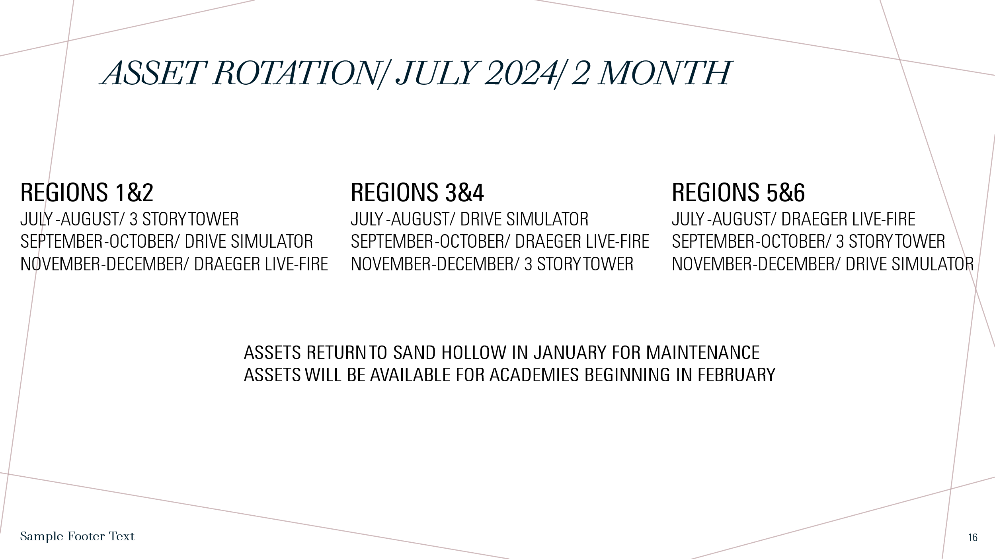
.
ASSET/ Training Prop Update.
05/05/25
Draeger-Sand Hollow Move To Rock Creek June 2, 2025 by Toby Robinson
3 Story Tower-Sand Hollow Move to South County Fire Conference June
Draeger move to SCFC Downey June 19, 2025 by Wynn Whitmeyer.
Drive Simulator-Central Fire

SRV Academy
Forcible Entry Props FE-22
3 Story Tower
Extrication Trailer VE

