FST Advisory Committee
Meeting Minutes

Date: 04/07/2025

Attendees:
Brad Terry
Breanna Gibson
Cindy Oostra
Deshan Cabong
Ben Doman,
Justin Capaul
Mark Mendez
Travis Myklebust
Keith Weissenfells
Steve Berg
Dustin Mirmontazeri
Darrin Raskopf

Old Business
- NFA WUI Class Idaho has been offered to host 1 NFA class for 30 participants: Course Description: “Wildland-Urban Interface Risk Assessment & Mitigation for the Fire Service”. FST will be reaching out to the field (IFCA, Advisory Council) for locations and a date. NFA requested April. Cancelled due to FEMA Contract Instructor Freeze. Possible future class. NFA/FEMA has been very quiet.
- SIFA Update
- Clearwater Planning
- Book Purchases Plan
- 1403 Live Fire/ Instructor II
- Update Skills/Tests
- Certs Update: Testing/ Training
- Academies / Clearwater/ SRV/ South County Fire Conference
- Training Equipment/ Ice Rescue/ HAZMAT Totes/ SIM Tables
- SOG Update.

New Business
- New Council Members; Ben Doman Industry Fire Agency Alternate, Replace Nick Terry for INL Industry Alternate Advisory Council Member. Sergeant Brandon Bake New ISP Advisory Council Representative replacing Deshan Cabong. Thank You Deshan for your input with FST for Law Enforcement.
- NFA/FEMA NFPA 1400 Class Kootenai County XX/XX/2025 CANCELLED
- Clearwater/ Update: Successful 230 Students, 48 Departments. Next year intend to get classes established early and call outs completed early.
- ISP HAZMAT Operations for Law Enforcement: Discussion about the requirements of Law Enforcement through State Statutes, LERA and IDAPA. ISP Brandon Bake and FST Instructor Rick Reddy are working on HAZMAT Training for Law Enforcement/ISP. Intention to make the class and training for future ISP Trainers.

- 1403 Live Fire/ Instructor II / 1403 Lead Instructor Work Group. Travis Myklebust is helping to develop curriculum. Hybrid training options. He attended IFSI 1403 Lead Live Fire Instructor Training recently. New NFPA requires an Instructor II level training for Live Fire Lead Instructor. FST will work on putting together a work group to review the 1403 Live Fire Lead Instructor and 1403 Live Fire curriculum. This new program will correct the gap between 1403 2012 and 2018 edistions. Recent events across the country establish the importance of proper 1403 compliance. Travis, Dustin Mirmontazeri, Ben Doman, Keith Weissenfels and Mike Mather will be part of the work group.

  - Foam Eductors and Training with Foam. Discussion on the use of eductors for testing (will built in apparatus foam eductors suffice for testing) . Check Correlation and JPR’s . What products or simulation should be used instead of harmful PFAS Foam.

- Update Skills/Tests/ Surveys/ Cindy Oostra
  - Driver-Operator-Newest Edition is out. Waiting for IFSAC Correlation to Validate. Will utilize Zoom Group Meetings for Test Validation. Working on Task Book Skills Testing.
  - HAZMAT TESTING-
    - HAZMAT Ops Skill Test: As discussed previously, skills dropped from 2 to 1 skill. Now all HAZMAT Levels will have 1 skill. HMA, HMO Core, MSC 9.2, 9.3, 9.4 and 9.6 will have a tested skill. Since 9.2 and 9.6 are required for FF1, 3 skills are tested during an HMO Test
  - Lead Evaluator Coordination/Upcoming Testing Events: 13/ 6 in April, 4 in May and 3 in June.
  - Steve Berg and FST Evaluators conducted HMA/HMO and all MSC 9.2-9.6 at Timberlake. Event was setup by 0900. They skill tested 23 students by 2:30 pm. 4 Fail Ops Core.
  - Fire Officer 2 and 3 IFSAC Tests were accepted by IFSAC Site Review. Testing is tentative to begin this summer.
  - Evaluator Survey sent out to establish a good contact list of Evaluators for testing. This list will also assist with establishing evaluators for new testing levels Driver/Operator Mobile Water Supply and Aerial. Many in the field have these levels from other states to qualify.
  - Dustin M asked about Evaluator Training. In the past FST had conducted training. Cindy is working on conducting training sessions for Evaluators soon. She wiil also work with Travis Myklebust to create more trainings in N Idaho. Intentions of doing the same in E Idaho.
  - Current Evaluators are Mentored only. Intend to develop some Online Evaluator Training.
- Certs Update: Testing/ Training TR2 Breanna Gibson
  - 472 Clearwater Academy Certs sent out by 2nd week of April. Would have been sooner but she was waiting on finalized rosters. 1252 total March Certs
- Academies /
  - SRV/ April 12-13, April 25-28. Draeger Trailer TtT class 4/25/25.
  - South County Fire Conference April 10-June 17, 2025. HOT (Hands On Training) Classes June 20-22.
  - Central Idaho Fire Academy/ Donnelly, Idaho/ September 26-28, 2025. Donnelly Fire with Jerry Holenbeck is bringing back an academy to this area.
- Training Equipment/ User Guide and Inventories Help. Will ask the field for assistance with these items.
- FST Processes/ Forms/ Requesting/ Approvals/ Budget
  - Testing: Forms are in new Microsoft Forms Format. Improving FST Processes and efficiency. Cindy has been the driving force for test forms.
  - Training: Moving from JotForm to Microsoft Forms. Trevi Hardy has been assisting as the interim Training Coordinator and driving the transition to Forms.
  - Budget: As the end of the fiscal year approaches. FST will analyze event costs to ensure the budget does not go over. So far it is looking good. Awaiting final amounts and last requests for June.
- SOG Update. Sending out the working document SOG and the most current Draft of the SOG. Finalize and Publish second week of May.
- ZOOM NEW MEETING ID: 847 1150 0431

Next Advisory Council Meeting: May 5, 2025
FST Advisory Council Meeting May 5, 2025
May 5, 2025. 01:00 PM Mountain Time (US and Canada)
https://us02web.zoom.us/j/85282783770?pwd=psVGiDCIrDxS13F5FX8J0wQ2Q3UQn3.1
Meeting ID 852 8278 3770
Passcode 645024
Security: Waiting Room
New Meeting ID 852 8278 3770

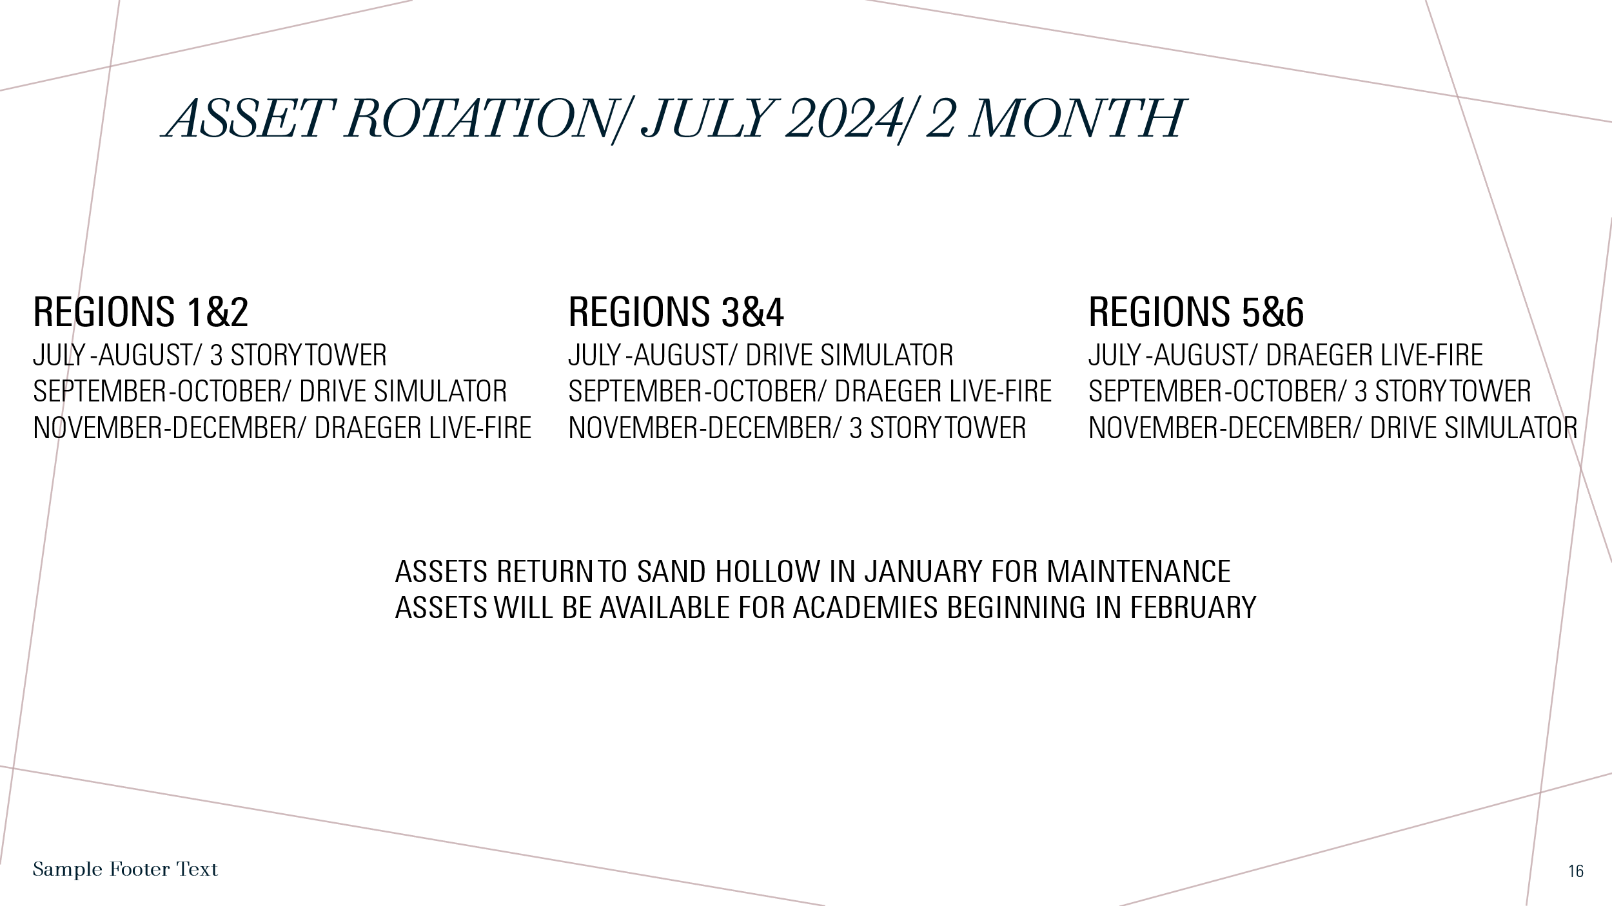
.
ASSET/ Training Prop Update.
April
SRV: Draeger-Sand Hollow /3 Story Tower-Sand Hollow/ Region 3&4 Extrication Trailer

Drive Simulator-Bonneville Co to Central Fire

Clearwater Academy Returns
Forcible Entry Props FE-21 to Kamiah and FE-22 Returned to Sand Hollow for SRV
3 Story Tower SRV

East Idaho
Extrication Trailer Bonneville Co to Idaho Falls

