FST Advisory Committee
Meeting Agenda

Date: 04/07/2025

Attendees:

Old Business
- NFA WUI Class Idaho has been offered to host 1 NFA class for 30 participants: Course Description: “Wildland-Urban Interface Risk Assessment & Mitigation for the Fire Service”. FST will be reaching out to the field (IFCA, Advisory Council) for locations and a date. NFA requested April. Cancelled due to FEMA Contract Instructor Freeze. Possible future class.
- SIFA Update
- Clearwater Planning
- Book Purchases Plan
- 1403 Live Fire/ Instructor II
- Update Skills/Tests
- Certs Update: Testing/ Training
- Academies / Clearwater/ SRV/ South County Fire Conference
- Training Equipment/ Ice Rescue/ HAZMAT Totes/ SIM Tables
- SOG Update.

New Business
- New Council Members; Ben Doman Industry Fire Agency Alternate, Replace Nick Terry. Sergeant Brandon Bake New ISP Alternate
- Clearwater/ Update
- ISP HAZMAT Operations for Law Enforcement
- 1403 Live Fire/ Instructor II / 1403 Lead Instructor Work Group.
- Update Skills/Tests/ Surveys/ Foam Eductors for D/O/ Lead Evaluator Coordination/ 13 Upcoming Events
- Certs Update: Testing/ Training 472 Clearwater, 1252 total March
- Academies / SRV/ South County Fire Conference
- Training Equipment/ User Guide Inventories Help
- FST Processes/ Forms/ Requesting/ Approvals/ Budget
- SOG Update.
- ZOOM NEW MEETING ID: 847 1150 0431

Next Advisory Council Meeting: May 5, 2025
FST Advisory Council Meeting May 5, 2025
May 5, 2025. 01:00 PM Mountain Time (US and Canada)
https://us02web.zoom.us/j/85282783770?pwd=psVGiDCIrDxS13F5FX8J0wQ2Q3UQn3.1
Meeting ID 852 8278 3770
Passcode 645024
Security: Waiting Room
New Meeting ID 852 8278 3770

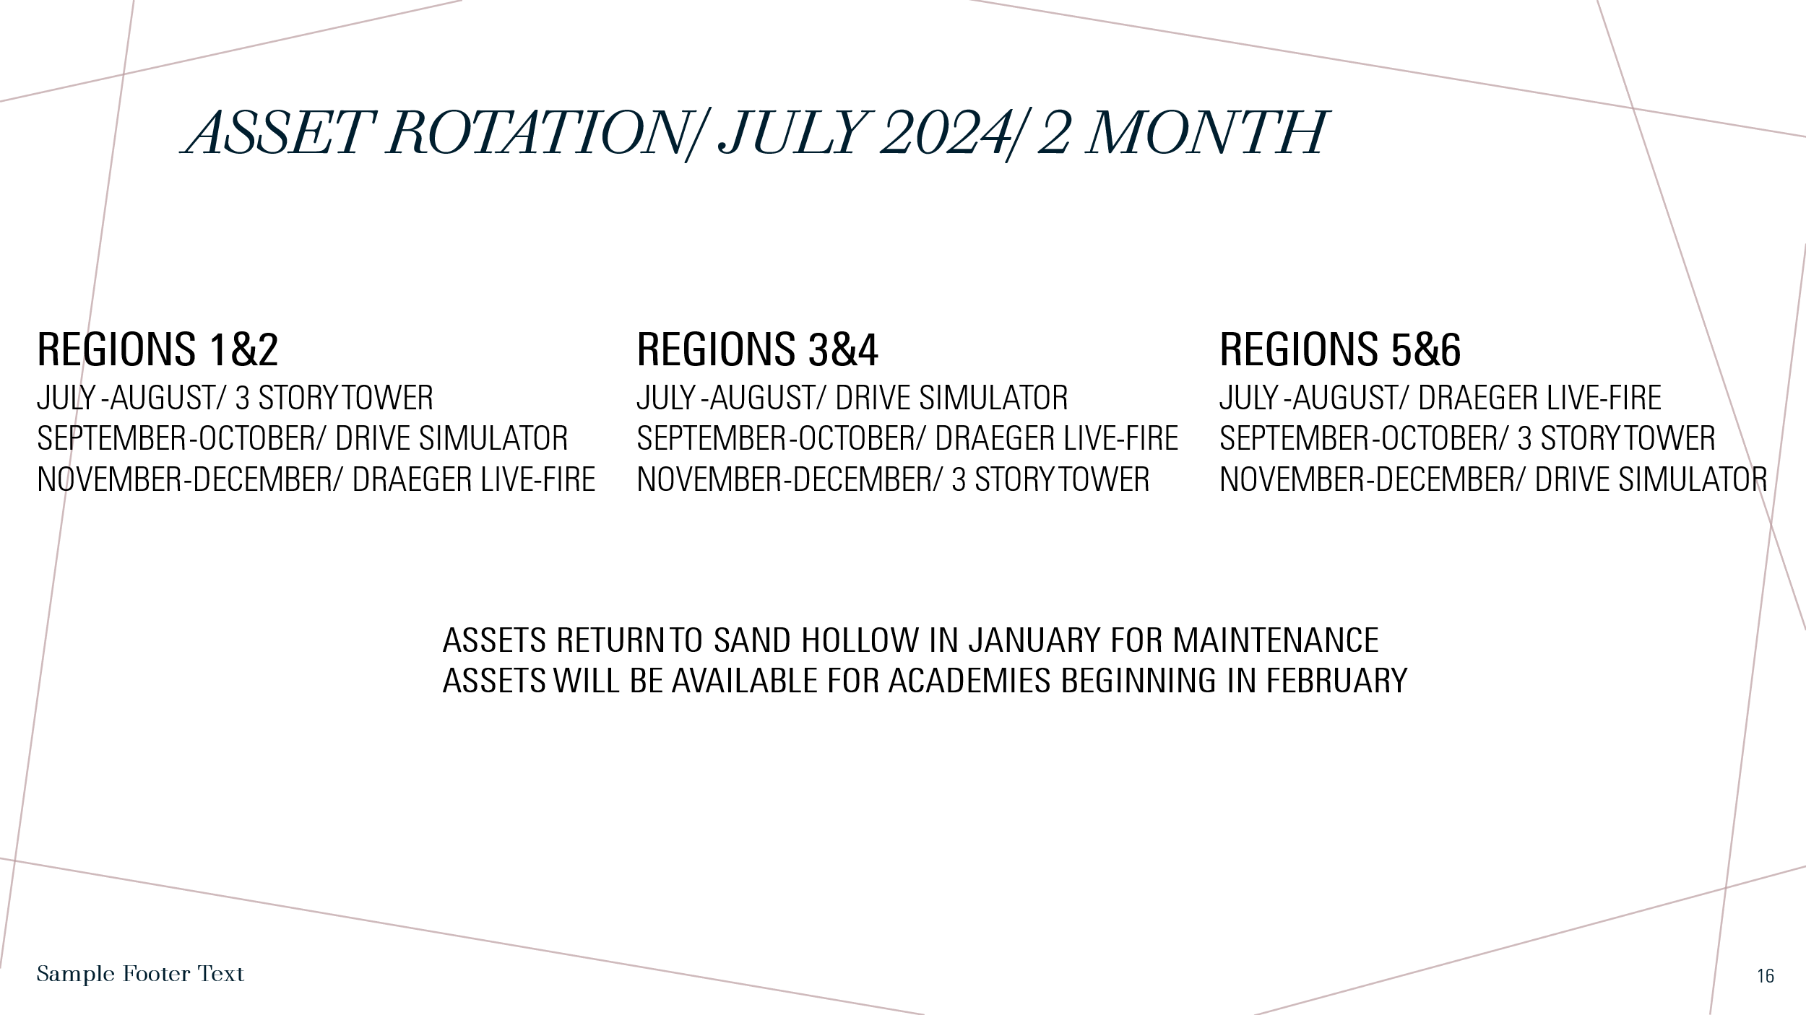
.
ASSET/ Training Prop Update.
April
SRV: Draeger-Sand Hollow /3 Story Tower-Sand Hollow/ Region 3&4 Extrication Trailer

Drive Simulator-Bonneville Co to Central Fire

Clearwater Academy Returns
Forcible Entry Props FE-21 to Kamiah and FE-22 Returned to Sand Hollow for SRV
3 Story Tower SRV

East Idaho
Extrication Trailer Bonneville Co to Idaho Falls

