**FST Advisory Committee**

**Meeting Agenda**

**Date: 01/06/2025**

Attendees:

Old Business

* New TR2 Position
* Certs Update: Testing/ Training
* Draeger Trailer/Transport and Maintenance/
* IFSAC Test Validation December
* Equivalency Update

New Business

* IFSAC Site Review Planning
* Certs Update: Testing/ Training
* Draeger Trailer/Transport and Maintenance/
* NFA WUI Class Idaho has been offered to host 1 NFA class for 30 participants: **Course Description:** “Wildland-Urban Interface Risk Assessment & Mitigation for the Fire Service”. FST will be reaching out to the field (IFCA, Advisory Council) for locations and a date. NFA requested April.
* Publisher Change from IFSTA to Jones and Bartlett for FF1, FFII, HMA/HMO. SOG Change: Requirement for 9.2 and 9.6 for FF1.
* **ZOOM NEW MEETING ID:** Meeting ID  **708 538 3248**
* **Debbie Carpenter Retirement/ Shane Anderson Northernlakes Fire replacement on Advisory Council.**
* **SOG Update.**

**Next Advisory Council Meeting: January 6, 2025**

Jan 6, 2025 01:00 PM Mountain Time (US and Canada)

ZOOM Link:  <https://us02web.zoom.us/j/7085383248?omn=85138513704>

Meeting ID  **708 538 3248**

Security: Waiting Room

Meeting ID: 880 3504 2130  
Passcode: 234208

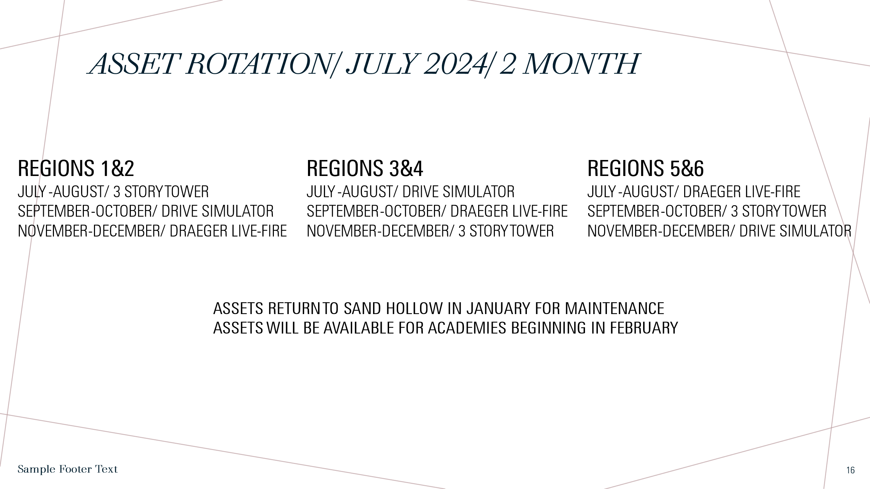

.

**ASSET/ Training Prop Update.**

**11/27/2024**

**Draeger-Lewiston/ December**

**3 Story Tower-Burley>12/4/24 New Plymouth**

**Drive Simulator-CTE Idaho Falls>12/13/24 Possibly Ammon or Twin Falls**