**FST Advisory Committee**

**Meeting Minutes**

**Date: 11/04/2024**

Attendees:

Debbie Carpenter

Darrin Raskopf

Mark Mendez

Trevi Hardy

Sandi Wiensz

Brad Terry

Old Business

* Certs Update: Testing/ Training/ Testing began again October 15th. Certs for testing are delayed due to staffing shortage but will be cought up in the coming weeks.

• IFSAC Test Validation November/ Delayed but planning for December

• IFSAC Review/ Application with Criteria Submitted Oct 1

• FST Rope Rescue Curriculum/ No Progress. The work Group is ready and waiting for FST to find a final member for Region 1 or 2 to begin.

• Future IFSAC Testing for Fire Officer II, III, Driver/Operator Mobile Water Supply and Aerial Apparatus. These should be ready for testing Spring/Summer

New Business

* New TR2 Position/ Hiring was not completed as of the meeting. 11/27/24 The new FST TR2 is Breanna Gibson. She has a lot of experience with CTE and State systems along with customer service and organization. She will be an asset to FST.
* Certs Update: Testing/ Training
  + SOG Change for IFSAC Testing/ Failure of a Skill. The change was sent out. Cindy explained the changes. All comments were positive for the change through email and at the meeting.
* Draeger Trailer/Transport and Maintenance/ Draeger went from Kamiah to Lewiston. Draeger is operating but needs maintenance. Draeger Rep from Canada was planned for 3rd week in November for maintenance and updates. It is now planned for the 2nd week in December with a cost of over $11,ooo. Travis Myklebust is coordinating the repairs.
* Drivers- The field has provided names from the regions to assist and working on hiring. The drivers have already helped. Toby Robinson and Tim Atwood have been moving props and will continue. Additional drivers will reduce costs and make moves more efficient.
* Key Lock Boxes will be installed on props to keep the keys with the props.
* Current Prop Locations as of 11/27/2024
  + Draeger-Lewiston
  + Drive Simulator-CTE Idaho Falls
  + 3 Story- Burey
  + Extrication, Forcible Entry are in their regions
* IFSAC Test Validation FF1/Region 3&4 and FF2/Region 5&6 planning for mid December
  + December is a very heavy IFSAC Testing time of year.
* SIFA February 14-16, 2024. Planning underway.
* SOG-Update on SOG Changes to align with IFSAC Changes and to make them more clear.

**Next Advisory Council Meeting: December 2, 2024**

Join Zoom Meeting  
<https://us02web.zoom.us/j/88035042130?pwd=UEJ5ajZVL2RhQkxrUUJraVFCMzNuZz09>

Meeting ID: 880 3504 2130  
Passcode: 234208

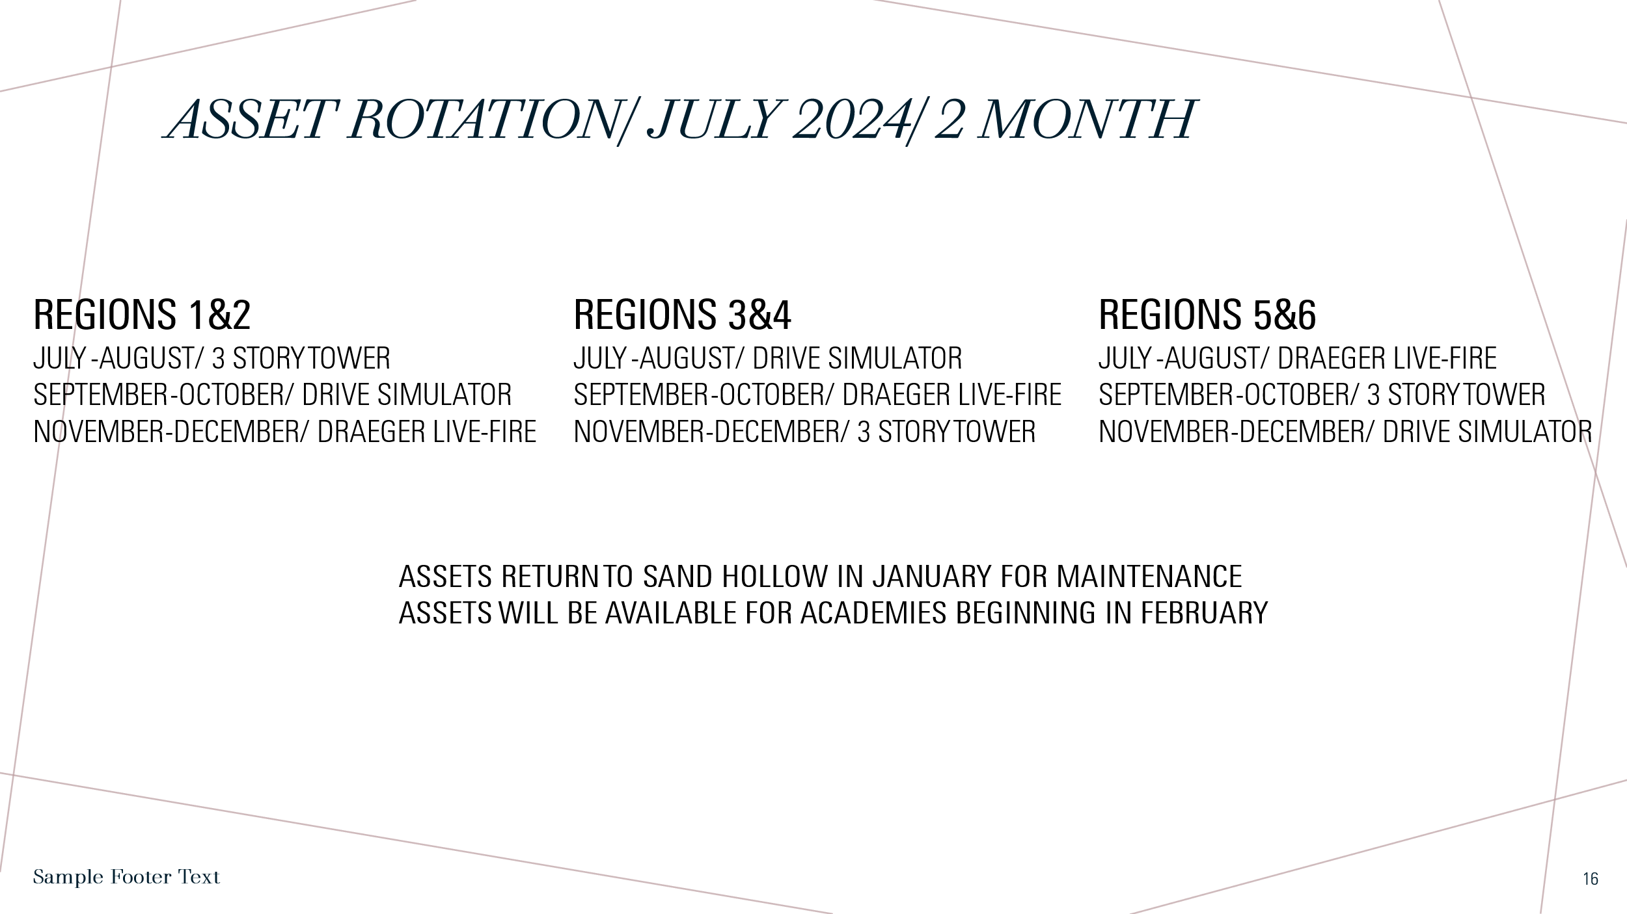

.

**ASSET/ Training Prop Update.**

**10/25/2024.**

**Draeger is in Kamiah. Move to Lewiston 1st week of November**

**3 Story Moves from Idaho Falls to Burley, October 30-December 5th.**

**Drive Simulator from Shoshone to Madison Fire October 29th. Will be in Region 5&6 through December.**

11/27/2024

* + Draeger-Lewiston
  + Drive Simulator-CTE Idaho Falls
  + 3 Story- Burley
  + Extrication, Forcible Entry are in their regions
  + Rope Rescue-In regions not available.