**FST Advisory Committee**

**Meeting Agenda**

**Date: 11/04/2024**

Attendees:

Old Business

* Certs Update: Testing/ Training

• IFSAC Test Validation November

• IFSAC Review/ Application with Criteria Submitted Oct 1

• FST Rope Rescue Curriculum

• Future IFSAC Testing for Fire Officer II, III, Driver/Operator Mobile Water Supply and Aerial Apparatus

New Business

* New TR2 Position
* Certs Update: Testing/ Training
* Draeger Trailer/Transport and Maintenance/
* IFSAC Test Validation Late September

**Next Advisory Council Meeting: December 2, 2024**

Join Zoom Meeting  
<https://us02web.zoom.us/j/88035042130?pwd=UEJ5ajZVL2RhQkxrUUJraVFCMzNuZz09>

Meeting ID: 880 3504 2130  
Passcode: 234208

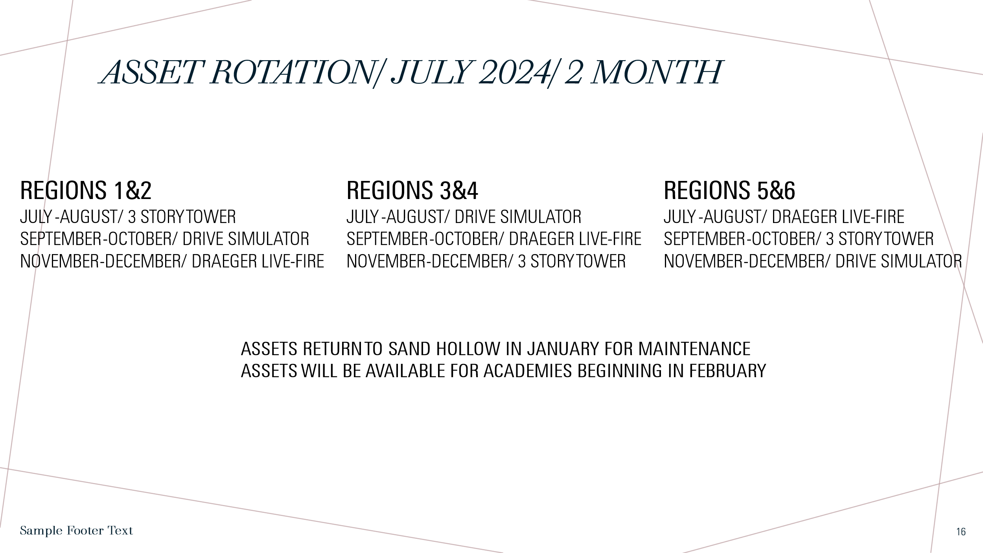

.

**ASSET/ Training Prop Update.**

**10/25/2024.**

**Draeger is in Kamiah. Move to Lewiston 1st week of November**

**3 Story Moves from Idaho Falls to Burley, October 30-December 5th.**

**Drive Simulator from Shoshone to Madison Fire October 29th. Will be in Region 5&6 through December.**