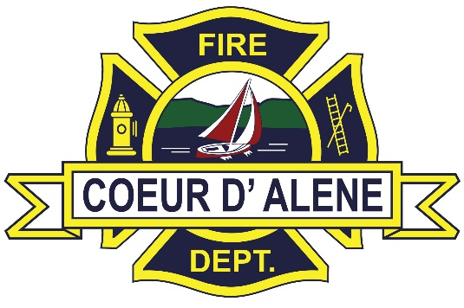

November 7th and 8th 2024

0800-1700

Coeur d’ Alene Station 2

3850 Ramsey Rd, CDA ID, 83815

**National Fire Academy F0609 Introduction to Unified Command for All-Hazard Incidents**

This 2-day course is designed to provide Company Officers (COs) with a better understanding of multiagency needs and a Unified Command structure. This course will provide the attendees with an understanding of the requirements of a Unified Command organization and provide learners with the knowledge and skills necessary to operate effectively in complex incidents.

The primary audience for the course is fire department COs, first responders, chief officers and others who would function in a Command or General Staff position during a multiagency operation. Further specification for the audience includes officers who have command responsibilities, are upwardly mobile and act in the position of a Command Officer, would function in a Command or General Staff position during a Unified Command operation, and are initially responsible for setting up the Incident Command organization.

Students taking the course, must have a FEMSID

Please RSVP to Amy Valadez @ [cdafire@cdaid.org](mailto:cdafire@cdaid.org)