Hazardous Materials Awareness
Skill Sheets

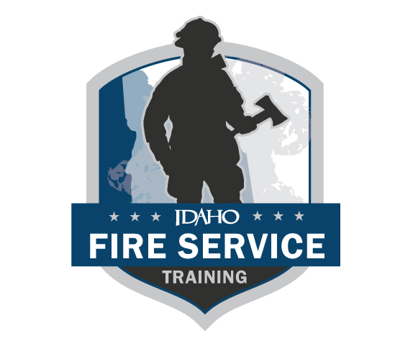
The following skills sheets are meant to be printed double-sided. This allows the candidate to view the instructions and description without viewing the steps. (REVISED 06/2024)

Evaluators are the FST on-site representative for IFSAC skills exams and are responsible for evaluating a candidate’s ability to perform specific skills in a structured testing situation. In rare occasions where enough evaluators are not available, FST may approve an evaluator who participated in the training process, as long as they do not evaluate the subject(s) they taught. Evaluators will only notify candidates of pass/fail status of a skill station if the candidate asks. All discussions between evaluators and the candidate about skill evaluations and scoring must be conducted after the candidate has completed the skill testing station, and in a location that will provide privacy from other candidates to ensure confidentiality. Evaluators complete the testing station skills sheets for each candidate and include any comments concerning the testing of the candidate and sign the skill sheet to affirm passing or failing of the skill by the candidate. Evaluators refer any problems or questions that develop during the testing process to the Lead Evaluator.

This page was intentionally left blank.

Hazardous Materials Awareness

Recognition and identification of hazardous materials/WMD incidents

Skill Sheet 1

Standard: NFPA 1072, 2017edition  Objective: 4.2.1, 4.2.1(B) | Task (read aloud): Recognizing and Identifying Hazardous Materials/WMD incidents.
Candidate directive (read aloud): Given a Hazardous Materials or WMD simulated incident you shall identify indicators of the problem and provide a scene size up and make the appropriate notifications.
NFPA requisite skill 4.2.1(B): Recognizing and identify Hazardous Materials/WMD and hazards involved in a Hazardous Materials/WMD incident, given a Hazardous Materials/WMD incident, and approved reference sources, so that the presence of Hazardous Materials/WMD is recognized and the materials and their hazards are identified.
Required equipment: Full PPE, Binoculars, ERG or SDS or shipping papers, pictures of placards, labels, or NFPA 704 markings, container identification charts, or other transportation markings.
Required personnel: 0 assistants

Hazardous Materials Awareness

Recognition and identification of hazardous materials/WMD incidents

Skill Sheet 1

Standard: NFPA 1072, 2017edition  Objective: 4.2.1, 4.2.1(B) |  | Task: Recognizing and Identifying Hazardous Materials/WMD incidents.
NO. | TASK STEPS |  | FIRST TEST |  | RETEST
 |  |  | Pass | Fail | Pass | Fail
1. | Acknowledge the task assignment to Evaluator.
2. | State the required equipment needed (Full PPE, ERG, Binoculars).
3. | Ensure uphill/upwind in a safe location.
4. | Obtain information from bystanders or those involved, if available.
5. | Provide an on scene size up.
6. | Verbalize indicators of a HM/WMD incident.
 | Utilizing an ERG, SDS, or shipping papers, identify the materials involved in the incident and potential hazards.
7. | Notify appropriate state/local agencies per AHJ SOP’s.
8. | Notify evaluator task is complete.
 | Did candidate complete skill swiftly, safely, and with competence?

Evaluator/candidate comments: __________________________________________________________________________________________________________________________________________________________________________

IFSAC Evaluator’s signature IFSAC EVALUATORS NAME - PRINTED

I acknowledge NOT passing this skill station.
Candidate’s signature

Hazardous Materials Awareness

Initiate protective actions

Skill Sheet 2

Standard: NFPA 1072, 2017edition  Objective: 4.3.1, 4.3.1(B), 4.4.1, 4.4.1(B), | Task (read aloud): Initiate protective actions at the scene of a Hazardous Materials/WMD incident.
Candidate directive (read aloud): Given a Hazardous Materials/WMD simulated incident you shall initiate protective actions, establish initial isolation distances, and notify appropriate state and local agencies.
NFPA requisite skills 4.3.1 and 4.4.1: Recognize precautions for protecting responders and the public; identifying isolation areas, denying entry, avoiding or minimizing hazards, and notification of appropriate agencies.
Required equipment: Full PPE, Binoculars, ERG or SDS or shipping papers, pictures of placards, labels, or NFPA 704 markings, container identification charts, or other transportation markings.
Required personnel: 0 assistants

Hazardous Materials Awareness

Initiate protective actions

Skill Sheet 2

Standard: NFPA 1072, 2017edition  Objective: 4.3.1, 4.3.1(B), 4.4.1, 4.4.1(B), |  | Task: Initiate protective actions at the scene of a Hazardous Materials/WMD incident.
NO. | TASK STEPS |  | FIRST TEST |  | RETEST
 |  |  | Pass | Fail | Pass | Fail
1. | Acknowledge the task assignment to Evaluator.
2. | State the required equipment needed (Full PPE, ERG, Binoculars).
3. | Ensure uphill/upwind in a safe location.
4. | Utilizing an ERG, SDS, or shipping papers, determine initial protective actions and isolation distances.
5. | Isolate the area and deny entry.
6. | Direct exposed people to a predetermined location for Decon and medical care.
7. | Notify appropriate state/local agencies per AHJ’s SOPs.
8. | Give a status update via a mobile or handheld radio.
9. | Notify evaluator task is complete.
 | Did candidate complete skill swiftly, safely, and with competence?

Evaluator/candidate comments: __________________________________________________________________________________________________________________________________________________________________________

IFSAC Evaluator’s signature IFSAC EVALUATORS NAME - PRINTED

I acknowledge NOT passing this skill station.
Candidate’s signature

hazardous materials awareness

skills test flow chart

DEMOSTRATED AND DOCUMENTED WITH THE LOCAL AHJ
MANIPULATED SKILLS TEST PASSED WITH 100% COMPENTENCY OF CRITICAL FAIL POINTS IDENTIFIED ON THE SKILL SHEET AT AN IDAHO DESIGNATED IFSAC TESTING SITE
DEMOSTRATED AND DOCUMENTED WITH THE LOCAL AHJ

sKILL SHEET 1: Recognition and identification of hazardous materials/WMD incidents

SKILL SHEET 2: Initiate protective actions

one skill will be chosen at random by fst

fst will provide the testing site with an erg to use in testing

A copy of all skill sheets can be found on the FST website. Testing | Idaho Division of Career Technical Education

