Driver Operator - General
Skill Sheets

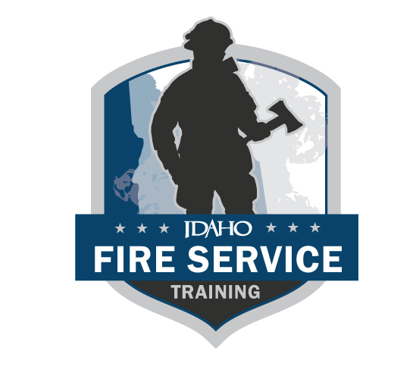
The following skills sheets are meant to be printed double-sided. This allows the candidate to view the instructions and description without viewing the steps. (REVISED 06/2024)

Evaluators are the FST on-site representative for IFSAC skills exams and are responsible for evaluating a candidate’s ability to perform specific skills in a structured testing situation. In rare occasions where enough evaluators are not available, FST may approve an evaluator who participated in the training process, as long as they do not evaluate the subject(s) they taught. Evaluators will only notify candidates of pass/fail status of a skill station if the candidate asks. All discussions between evaluators and the candidate about skill evaluations and scoring must be conducted after the candidate has completed the skill testing station, and in a location that will provide privacy from other candidates to ensure confidentiality. Evaluators complete the testing station skills sheets for each candidate and include any comments concerning the testing of the candidate and sign the skill sheet to affirm passing or failing of the skill by the candidate. Evaluators refer any problems or questions that develop during the testing process to the Lead Evaluator.

This page was intentionally left blank.

Driver Operator - General

Routine test, inspection and servicing functions

Skill Sheet 1

Standard: NFPA 1002, 2017 edition  Objective: 4.2.1, 4.2.2, 4.3.7 | Task (read aloud): Given an apparatus appropriate to the level of certification, perform and document routine test, inspection, and servicing functions on specified systems and components.  This skill will be performed for every level of driver certification being tested for on each of those apparatus.
Candidate directive (read aloud): Perform visual and operational checks on the systems and components specified in the provided list, given a fire department vehicle, its manufacturer’s specifications, and policies and procedures of the jurisdiction, so that the operational status of the vehicle is verified.

Document the visual and operational checks, given maintenance and inspection forms, so that all items are checked for operation and deficiencies are reported.

4.3.7 Operate all fixed systems and equipment on the vehicle not specifically addressed elsewhere in the standard.
NFPA Requisite skill 4.2.1 (B): The ability to use hand tools, recognize system problems, and correct any deficiency noted according to policies and procedures.

NFPA Requisite skill 4.2.2 (B): The ability to use tools and equipment and complete all related departmental forms.

NFPA Requisite skill 4.3.7 (B): The ability to deploy, energize, and monitor the system or equipment.
Required equipment: Flashlight, pen, clipboard, check sheet either by FST or by jurisdiction (proctor must identify that all items from skill sheet 1 General Driver Operator are present), paper towel/rag, any other hand tools required to make access for checks.
Required personnel: 0 assistants

Driver Operator - General

Routine test, inspection and servicing functions

Skill Sheet 1

Standard: NFPA 1002, 2017 edition  Objective: 4.2.1, 4.2.2, 4.3.7 |  | Task: Perform and document routine test, inspection and servicing functions on specified systems and components.
Performance outcome: Given a fire department apparatus, the necessary hand tools, and using the provided vehicle inspection checklist (DO1), the candidate shall complete and document an inspection as outlined below, not to exceed 25 minutes (provide flashlight, pen, clipboard, paper towel/rag):
 |  |  | FIRST TEST |  | RETEST
NO. | TASK STEPS |  | Pass | Fail | Pass | Fail
1. | Candidate inspect apparatus as they approach looking for signs of damage or leaks.
2. | Check batteries for fluid level and corrosion.
3. | Check braking system fluid level or for air level and drain moisture from air tanks.
4. | Check coolant system for fluid levels, leaks, cleanliness.
5. | Check electrical system including: warning devices, headlights, running lights, turn signals, and warning lights.
6. | Check fuel level.
7. | Check hydraulic fluids for level and leaks (if applicable).
8. | Check engine for leaks.
9. | Check engine oil level.
10. | Check tires for pressure and wear, (tread depth minimum : front 4/32”, rear 2/32”).
11. | Check steering system for range of motion and excessive looseness.
12. | Check engine belts for tightness and wear.
13. | Check tools, appliances, equipment, lighting.
14. | Check windshield, wiper blades, and washer fluid.
15. | Check Safety Features (seat belts, guards, hand grabs etc.).
16. | Start apparatus, monitor gauges and control devices.
17. | Document and correctly report any deficiencies.
18. | Completed in 25 minutes or less.
 | Did the candidate perform the skill safely, swiftly, and with competence?

Evaluator/candidate comments: __________________________________________________________________________________________________________________________________________________________________________________

IFSAC Evaluator’s signature IFSAC EVALUATORS NAME - PRINTED

I acknowledge NOT passing this skill station.
Candidate’s signature

DRIVER OPERATOR – GENERAL – SKILL SHEET 1 (DO1)

Standard 4.2.1, 4.2.2 NFPA 1002, 2017 edition

Candidate’s name: Date:

OK Needs service
Battery

Braking system

Coolant system

Electrical system

Fuel

Hydraulic fluids

Oil

Tires

Steering system

Belts

Tools, appliances, and equipment

Windshield, wipers, fluid

Safety features

Vehicle is serviceable Vehicle is not serviceable

Comments about items needing service:
________________________________________________________________________________________________________________________________________________________________________________________________________________________________________________________________________________________________________________

Evaluator’s name: Date:

This page was intentionally left blank.

Driver Operator - General

Driver rodeo

Skill Sheet 2A LOCAL VERIFICATION This form is to be kept in a retrievable format by the AHJ.

Standard: NFPA 1002, 2017 edition  Objective: | Task (read aloud): Given an apparatus appropriate to the level of certification, operate the fire apparatus according to the scenario given that incorporates the maneuvers and features that the driver/operator is expected to encounter during normal operations, so that the vehicle is operated in compliance with all applicable state and local laws and departmental rules and regulations.  Both skills 2A and 2B are mandatory for each level being tested for. (Pumper, Aerial, Tender, etc.)  The Authority Having Jurisdiction will administer these JPR’s prior to the candidate participating in the Driver/Operator Practical.
Candidate directive (read aloud): Operate a fire apparatus, given a vehicle and a predetermined route on a public way that incorporates the maneuvers and features that the driver/operator is expected to encounter during normal operations, so that the vehicle is operated in compliance with all applicable state and local laws and departmental rules and regulations.

- Describes “alley dock.”
- Describes “serpentine.”
- Describes “confined space turnaround” (180).
- Describes “diminishing clearance.”
- Describes performing all of the above safely.
NFPA Requisite skill 4.3.1, 4.3.6 (B): The ability to operate passenger restraint devices; maintain safe following distances; maintain control of the vehicle while accelerating, decelerating, and turning, given road, weather, and traffic conditions; operate under adverse environmental or driving surface conditions; and use automotive gauges and controls.

NFPA Requisite Skill 4.3.2, 4.3.3, 4.3.4, 4.3.5 (B): The ability to use mirrors and judge vehicle clearance.
Required equipment: Apparatus appropriate to the position being tested for.
Required personnel: 1 assistant

Driver Operator - General

Routine test, inspection and servicing functions

Skill Sheet 2A LOCAL VERIFICATION This form is to be kept in a retrievable format by the AHJ.

Standard: 4.3.6 NFPA 1002, 2017 edition |  | Task: Operate a fire department apparatus appropriate to the level being tested while using defensive driving techniques so that control of the vehicle is maintained.
Performance outcome: The Authority Having Jurisdiction will administer this JPR prior to the candidate participating in the Driver/Operator Practical. It is recommended that this skill be conducted on a driving track or nonpublic roadway.
Conditions: Given a fire department pumping apparatus and a predetermined routs and a given assignment, the candidate shall demonstrate defensive driving skills by operating the vehicle in a safe manner to accomplish the tasks listed below.
NO. | TASK STEPS |  | FIRST TEST |  | RETEST
 |  |  | Pass | Fail | Pass | Fail
1. | Ensures vehicle is prepared for departure.
2. | Ensures all personnel are seated with safety belts fastened.
3. | Enters traffic in a safe manner.
 | Skill sheet 2A1
 | Skill sheet 2A2
 | Skill sheet 2A3
 | Skill sheet 2A4
 | a. Maintains control of the vehicle while accelerating, decelerating, and turning, given road, weather, and traffic conditions.
 | b. Operating under adverse environmental or driving surface conditions and maintains safe following distances.
 | c. Use automotive gauges and controls appropriately.
4. | Brings apparatus to a safe stop.
5. | Did the candidate perform the skill safely?

AHJ Evaluator/candidate comments: __________________________________________________________________________________________________________________________________________________________________________________

AHJ’S signature AHJ NAME - PRINTED

I acknowledge NOT passing this skill station.
Candidate’s signature

This form is to be kept in a retrievable format by the AHJ.

Driver Operator - General

Routine test, inspection and servicing functions

Skill Sheet 2A2 LOCAL VERIFICATION This form is to be kept in a retrievable format by the AHJ.

Standard: NFPA 1002, 2017 edition  Objective: 4.3.2 |  | Task: Back a vehicle from a roadway into a restricted space on both the right and let sides of the vehicle (alley dock).
Performance outcome: Given a fire department pumping apparatus, back the vehicle from a roadway into a restricted space on both the right and left sides of the vehicle into a restricted space 12ft in width, requiring 90-degree right-hand or left-hand turns from the roadway, so that the vehicle is parked within the restricted area without having to stop and pull forward and without striking obstructions. A spotter will be used as appropriate to the policies of the AHJ.

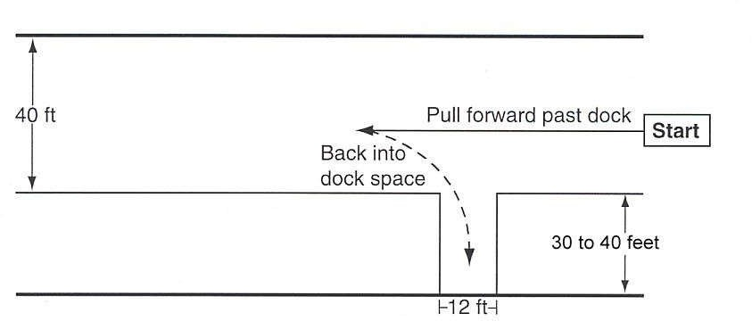
NO. | TASK STEPS |  | FIRST TEST |  | RETEST
 |  |  | Pass | Fail | Pass | Fail
1. | Adjust and use mirrors for backing.
2. | Driver and passenger(s) wearing seatbelts.
3. | Complete skill correctly without crossing over or striking cones.
4. | Complete skill without having to stop and pull forward.
5. | Driver spots apparatus completely within restricted space.
6. | Did the candidate perform the skill safely?

AHJ Evaluator/candidate comments: __________________________________________________________________________________________________________________________________________________________________________________

AHJ’S signature AHJ NAME - PRINTED

I acknowledge NOT passing this skill station.
Candidate’s signature

This form is to be kept in a retrievable format by the AHJ.
Driver Operator - General

Routine test, inspection and servicing functions

Skill Sheet 2A2 LOCAL VERIFICATION This form is to be kept in a retrievable format by the AHJ.

Standard: NFPA 1002, 2017 edition  Objective: 4.3.3 |  | Task: Maneuver fire department pumper around obstructions on a roadway while moving forward and in reverse (serpentine).
Performance outcome: Given a fire department pumping apparatus, back the vehicle from a roadway into a restricted space on both the right and left sides of the vehicle into a restricted space 12ft in width, requiring 90-degree right-hand or left-hand turns from the roadway, so that the vehicle is parked within the restricted area without having to stop and pull forward and without striking obstructions. A spotter will be used as appropriate to the policies of the AHJ.

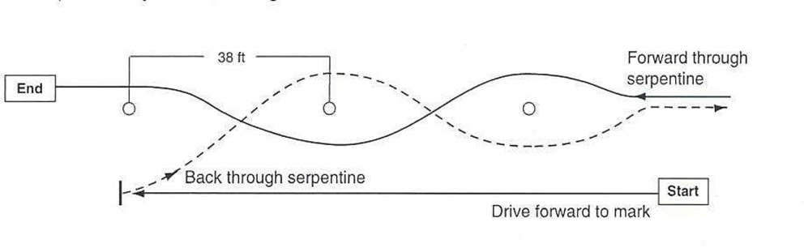
NO. | TASK STEPS |  | FIRST TEST |  | RETEST
 |  |  | Pass | Fail | Pass | Fail
1. | Adjust and use mirrors for backing.
2. | Driver and passenger(s) wearing seatbelts.
3. | Complete skill correctly without crossing over or striking cones.
4. | Complete skill without having to stop and pull forward.
5. | Did the candidate perform the skill safely?

AHJ Evaluator/candidate comments: __________________________________________________________________________________________________________________________________________________________________________________

AHJ’S signature AHJ NAME - PRINTED

I acknowledge NOT passing this skill station.
Candidate’s signature

This form is to be kept in a retrievable format by the AHJ.

Driver Operator - General

Routine test, inspection and servicing functions

Skill Sheet 2A3 LOCAL VERIFICATION This form is to be kept in a retrievable format by the AHJ.

Standard: NFPA 1002, 2017 edition  Objective: 4.3.4 |  | Task: Turn a fire department pumping apparatus around 180 degrees within a confined space.
Performance outcome: Given a fire department pumping apparatus, cones, and a confined area where the vehicle cannot perform a U-turn without stopping and backing up, the candidate shall maneuver the apparatus so that the vehicle is turned 180 degrees without passing over striking obstructions within the given space. A spotter will be used as appropriate to the policies of the AHJ.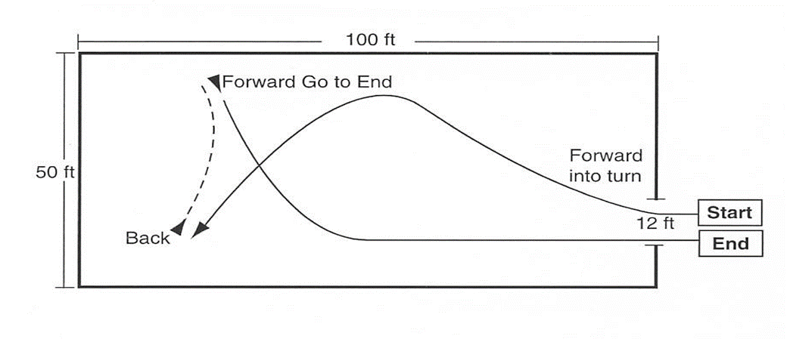
NO. | TASK STEPS |  | FIRST TEST |  | RETEST
 |  |  | Pass | Fail | Pass | Fail
1. | Adjust and use mirrors for backing.
2. | Driver and passenger(s) wearing seatbelts.
3. | Complete skill correctly without crossing over or striking cones.
4. | Did the candidate perform the skill safely?

AHJ Evaluator/candidate comments: __________________________________________________________________________________________________________________________________________________________________________________

AHJ’S signature AHJ NAME - PRINTED

I acknowledge NOT passing this skill station.
Candidate’s signature

This form is to be kept in a retrievable format by the AHJ.
Driver Operator - General

Routine test, inspection and servicing functions

Skill Sheet 2A4 LOCAL VERIFICATION This form is to be kept in a retrievable format by the AHJ.

Standard: NFPA 1002, 2017 edition  Objective: 4.3.5 |  | Task: Turn a fire department pumping apparatus around 180 degrees within a confined space.
Performance outcome: Maneuver a fire department pumping apparatus in restricted horizontal and vertical clearances (diminishing clearance).
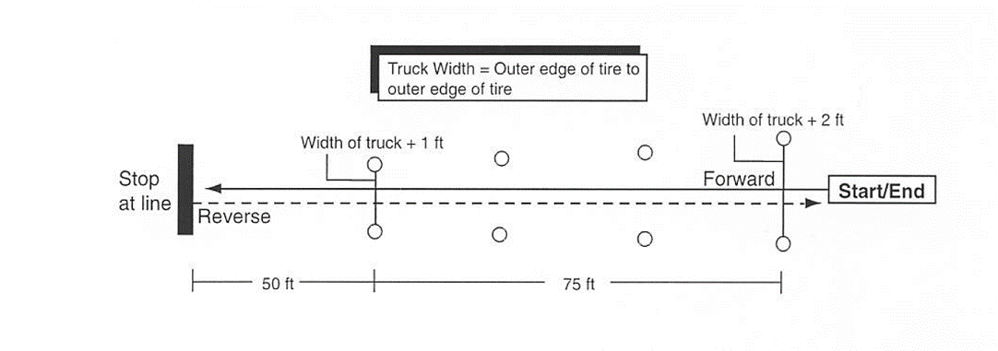

NO. | TASK STEPS |  | FIRST TEST |  | RETEST
 |  |  | Pass | Fail | Pass | Fail
1. | Adjust and use mirrors for backing.
2. | Driver and passenger(s) wearing seatbelts.
3. | Complete skill correctly without crossing over or striking cones.
4. | When asked, the candidate correctly provided the height of and location of the highest point of the apparatus. Answer shall be within 6 inches, but NOT less than the actual height.
5. | Did the candidate perform the skill safely?

AHJ Evaluator/candidate comments: __________________________________________________________________________________________________________________________________________________________________________________

AHJ’S signature AHJ NAME - PRINTED

I acknowledge NOT passing this skill station.
Candidate’s signature

This form is to be kept in a retrievable format by the AHJ.
Driver Operator - General

Routine test, inspection and servicing functions

Skill Sheet 2B LOCAL VERIFICATION This form is to be kept in a retrievable format by the AHJ.

Standard: NFPA 1002, 2017 edition  Objective: 4.3.1 |  | Task: Drive a fire department pumping apparatus appropriate to the specific level being tested for safely over a predetermined route on public roadway.
The Authority Having Jurisdiction will administer this JPR prior to the candidate participating in the Driver/Operator Practical. Any situations in the list below that do not exist in the host department’s jurisdiction may be omitted.
Conditions: Given a predetermined route on a public way that incorporates the maneuvers and features that the driver/operator is expected to encounter during normal operations, so that the apparatus is operated in compliance with all applicable state and local laws as well as department rules and regulations.
NO. | TASK STEPS |  | FIRST TEST |  | RETEST
 |  |  | Pass | Fail | Pass | Fail
1. | Ensures vehicle is prepared for departure.
2. | Ensures all personnel are seated with safety belts fastened.
3. | Enters traffic in a safe manner.
4. | Four left turns and four right turns.
5. | A straight section of urban street or rural two-lane road at least a mile in length.
6. | One through-intersection and two intersections where a stop has to be made.
7. | One railroad crossing.
8. | One curve, either left or right.
9. | A section of limited-access highway that includes a conventional ramp entrance and exit and a section of road long enough to allow lane changes.
10. | A downgrade or up-grade requiring gear changing to maintain speed.
11. | One underpass or low clearance bridge or obstacle.
 | a. Maintains safe following distances.
 | b. Maintains control of the vehicle while accelerating, decelerating, and turning, given road, weather, and traffic conditions.
 | c. Operating under adverse environmental or driving surface conditions and maintains safe following distances.
 | d. Use automotive gauges and controls appropriately.
12. | Did the candidate perform the skill safely?

AHJ Evaluator/candidate comments: __________________________________________________________________________________________________________________________________________________________________________________

AHJ’S signature AHJ NAME - PRINTED

I acknowledge NOT passing this skill station.
Candidate’s signature

This form is to be kept in a retrievable format by the AHJ.
This page was intentionally left blank.

Driver Operator - General

Fire department communications

Skill Sheet 3 LOCAL VERIFICATION This form is to be kept in a retrievable format by the AHJ.

Standard: NFPA 1002, 2017 edition  Objective:: 4.4.1, 4.4.2, 4.4.3, 4.4.4 | Task (read aloud): Utilize assigned departmental communication device in accordance with your jurisdictional SOP’s and etiquette standard.
4.4.1 Initiate the response to a reported emergency.

4.4.2 Receive a telephone call.

4.4.3 Transmit and receive messages via the fire department radio.

4.4.4 Activate emergency procedures.
NFPA requisite skill 4.4.1 (B): The ability to operate fire department communications equipment, relay information, and record information.

NFPA requisite skill 4.4.2 (B): The ability to operate fire station telephone and intercom equipment.

NFPA requisite skill 4.4.3 (B): The ability to operate radio equipment and discriminate between routing and emergency traffic.

NFPA requisite skill 4.4.4 (B): The ability to activate emergency procedures in accordance with the department’s SOPs
Required equipment: Communications equipment appropriate to the scenario, pen and paper
Required personnel: 0 assistants

Driver Operator - General

Initiate response to a reported emergency

Skill Sheet 3A LOCAL VERIFICATION This form is to be kept in a retrievable format by the AHJ.

Standard: NFPA 1002, 2017 edition  Objective: 4.4.1, 4.4.2, 4.4.3, 4.4.4 |  | Task: This duty shall involve initiating responses, receiving telephone calls, and using fire department communications equipment to correctly relay verbal or written information.
The Authority Having Jurisdiction will administer this JPR prior to the candidate participating in the Driver/Operator Practical.
4.4.1: Initiate the response to a reported emergency, given the report of an emergency, fire department SOP’s and communication equipment, so that all necessary information is obtained, communication equipment is operated correctly, and the information is relayed promptly and accurately to the dispatch center.
4.4.2: Receive a telephone call, given a fire department phone, so that procedures for answering the phone are used and the caller’s information is relayed.
4.4.3: Transmit and receive messages via the fire department radio, given a fire department radio and operating procedures, so that the information is accurate, complete, clear, and relayed within the time established by the AHJ.
4.4.4: Activate emergency procedures, given an emergency and department SOP’s, so that emergency actions can be initiated.
NO. | TASK STEPS |  | FIRST TEST |  | RETEST
 |  |  | Pass | Fail | Pass | Fail
Skill Sheet 3A | Initiate response to a reported emergency
Skill Sheet 3B | Receive a telephone call
Skill Sheet 3C | Transmit and receive messages via the fire department radio
Skill Sheet 3D | Activate emergency procedures

AHJ Evaluator/candidate comments: __________________________________________________________________________________________________________________________________________________________________________________

AHJ’S signature AHJ NAME - PRINTED

I acknowledge NOT passing this skill station.
Candidate’s signature

This form is to be kept in a retrievable format by the AHJ.

Driver Operator - General

Initiate response to a reported emergency

Skill Sheet 3A LOCAL VERIFICATION This form is to be kept in a retrievable format by the AHJ.

Standard: NFPA 1002, 2017 edition  Objective: 4.4.1 |  | Task (read aloud): Initiate a response to a reported emergency according to department standard operating procedures.
Candidate directive (read aloud): Given the report of an emergency either from an individual in person or over the phone, you will initiate an emergency response according to your local policies and procedures.
NO. | TASK STEPS |  | FIRST TEST |  | RETEST
 |  |  | Pass | Fail | Pass | Fail
1. | Acknowledge the task assignment to evaluator.
2. | State the required equipment needed (pen and paper, radio or telephone).
3. | If report is by telephone, answers phone promptly identifying their name and department.
4. | Identify the nature of the emergency from the reporting party.
5. | Determine life threat based on information received.
6. | Record and verify the proper address of the incident.
7. | Record name and number of reporting party.
8. | Relay information to dispatch as per local protocols.
9. | Notify evaluator when task is complete.
 | Did candidate complete skill swiftly, safely, and with confidence?

AHJ Evaluator/candidate comments: __________________________________________________________________________________________________________________________________________________________________________________

AHJ’S signature AHJ NAME - PRINTED

I acknowledge NOT passing this skill station.
Candidate’s signature

This form is to be kept in a retrievable format by the AHJ.
Driver Operator - General

Receive a telephone call

Skill Sheet 3B LOCAL VERIFICATION This form is to be kept in a retrievable format by the AHJ.

Standard: NFPA 1002, 2017 edition  Objective: 4.4.2 |  | Task (read aloud): Receive a department telephone call, document and pass on the information.
Candidate directive (read aloud): You will answer a simulated non-emergency telephone call on a public telephone number at the Fire Station and given a request to speak to someone.
NO. | TASK STEPS |  | FIRST TEST |  | RETEST
 |  |  | Pass | Fail | Pass | Fail
1. | Acknowledge the task assignment to evaluator.
2. | State the required equipment needed (pen & paper, telephone).
3. | Answer the call promptly.
4. | Identify yourself and the department to the caller.
5. | Document pertinent information to include: date, time, caller’s name, callers call back number, message and your name as the person taking the call.
6. | End the call courteously and in a timely manner, hang up after the caller.
7. | Deliver message to intended recipient.
8. | Notify evaluator when task is complete.
 | Did candidate complete skill swiftly, safely, and with confidence?

AHJ Evaluator/candidate comments: __________________________________________________________________________________________________________________________________________________________________________________

AHJ’S signature AHJ NAME - PRINTED

I acknowledge NOT passing this skill station.
Candidate’s signature

This form is to be kept in a retrievable format by the AHJ.
Driver Operator - General

Transmit and receive messages via the fire department radio

Skill Sheet 3C LOCAL VERIFICATION This form is to be kept in a retrievable format by the AHJ.

Standard: NFPA 1002, 2017 edition  Objective: 4.4.3 |  | Task (read aloud): Transmit and receive messages via the fire department radio.
Candidate directive (read aloud): Given a scripted message read aloud to you consisting of either routine or emergency traffic, you shall respond over a radio with the accurate, complete, and clear responses for the scenario given.
NO. | TASK STEPS |  | FIRST TEST |  | RETEST
 |  |  | Pass | Fail | Pass | Fail
1. | Acknowledge the task assignment to evaluator.
2. | State the required equipment needed (department radio).
3. | Ensure the radio is on and tuned to the appropriate frequency/channel.
4. | Use departments operating procedures to determine if routine or emergency traffic.
5. | A. Routine traffic: Wait until traffic is clear before transmitting.
6. | B. Emergency traffic: Announce, “Emergency traffic.”
7. | Have microphone 1 to 2 inches away from mouth (or speaking device of SCBA).
8. | Initiate transmission by identifying unit being called, then identifying yourself.
9. | Speak calmly, clearly, distinctly, and at a medium speed.
10. | Transmit a brief and accurate message.
 | Acknowledge and respond appropriately to all received messages.

AHJ Evaluator/candidate comments: __________________________________________________________________________________________________________________________________________________________________________________

AHJ’S signature AHJ NAME - PRINTED

I acknowledge NOT passing this skill station.
Candidate’s signature

This form is to be kept in a retrievable format by the AHJ.
Driver Operator - General

Activate emergency procedures

Skill Sheet 3D LOCAL VERIFICATION This form is to be kept in a retrievable format by the AHJ.

Standard: NFPA 1002, 2017 edition  Objective: 4.4.4 |  | Task (read aloud): Activate or initiate emergency procedures per department policy or SOGs.
Candidate directive (read aloud): Given a scripted message consisting of an emergency requiring you to initiate an emergency action, you will take the necessary actions.
NO. | TASK STEPS |  | FIRST TEST |  | RETEST
 |  |  | Pass | Fail | Pass | Fail
1. | Acknowledge the task assignment to evaluator.
2. | State the required equipment needed (department radio, air horn).
3. | Receive trigger for emergency (mayday, emergency evacuation, etc.)
4. | Utilizing department SOP’s activate emergency signal.
5. | Notify evaluator when task is complete.
6. | Explain to evaluator your role in the emergency signal and actions to take immediately after. (Observing conditions, assist with PAR) Follow SOPs.
 | Did candidate complete skill swiftly, safely, and with confidence?

AHJ Evaluator/candidate comments: __________________________________________________________________________________________________________________________________________________________________________________

AHJ’S signature AHJ NAME - PRINTED

I acknowledge NOT passing this skill station.
Candidate’s signature

This form is to be kept in a retrievable format by the AHJ.

Fire Apparatus Driver Operator-GENERAL

skills test flow chart
DEMOSTRATED AND DOCUMENTED WITH THE LOCAL AHJ
SIGNED LOCAL VERIFICATION FORM ON FILE WITH FST
sKILL SHEET 2: GENERAL DRIVER/OPERATOR DRIVER/OPERATING
SKILL SHEET 2A, 2A1, 2A2, 2A3, 2A4, AND 2B: dRIVER RODEO
SKILL SHEET 3: FIRE DEPARTMENT COMMUNICATIONS
SKILL SHEET 3A: INITIATE RESPONSE TO A REPORTED EMERGENCY
SKILL SHEET 3B: receive A TELEPHONE CALL
SKILL SHEET 3C: TRANSMIT AND RECIVE messages VIA THE FIRE DPERTMENT RADIO
SKILL SHEET 3D: ACTIVATE EMERGENCY PROCEDURES

DEMOSTRATED AND DOCUMENTED WITH THE LOCAL AHJ
MANIPULATED SKILLS TEST PASSED WITH 100% COMPENTENCY OF CRITICAL FAIL POINTS IDENTIFIED ON THE SKILL SHEET AT AN IDAHO DESIGNATED IFSAC TESTING SITE
DEMOSTRATED AND DOCUMENTED WITH THE LOCAL AHJ
sKILL SHEET 1: rOUTINE TEST, INSPECTION AND SERVICING FUNCTIONS

- VEHICLE INSPECTION CHECKLIST – DO1 PROVIDED AT TEST SITE
STANDARD 4.2.1, 4.2.2, NFPA 1002, 2017 EDITION

A copy of all skill sheets can be found on the FST website. Testing | Idaho Division of Career Technical Education

